

**Welcome to ISP**

C:\Users\tracey.sorrell\AppData\Local\Microsoft\Windows\INetCache\Content.MSO\15224F9F.tmp

Child’s name here



**What is foster care?**

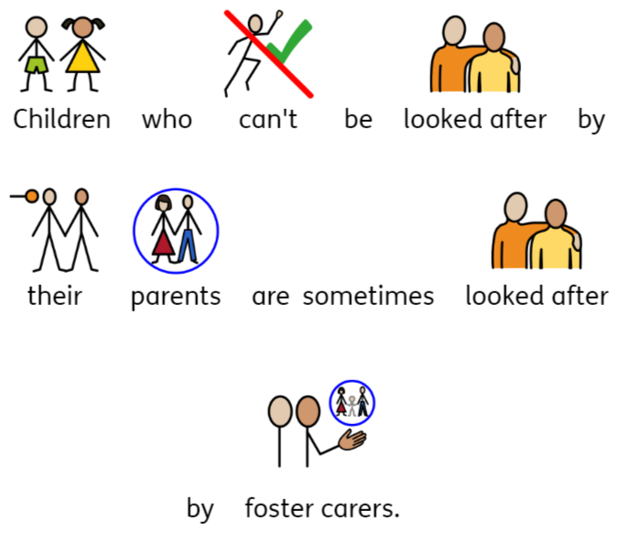

Children who can’t be looked after by



their parents are sometimes looked after



by foster parents



**You have come to live with**



Name of foster family here

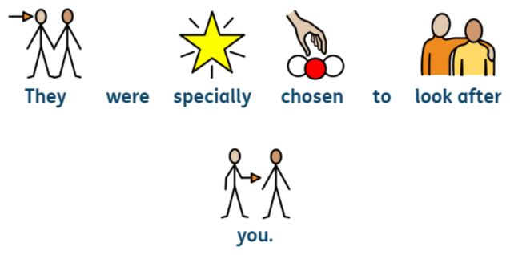

They were specially chosen to look after



you.



They will care for you and



keep you safe.

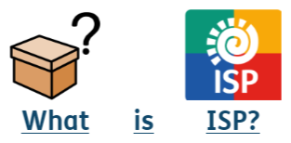

**What is ISP?**

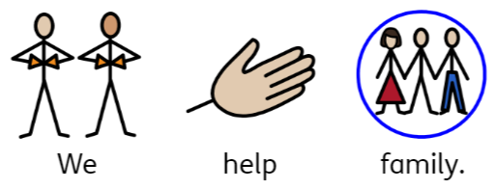

We help [name of foster parents]

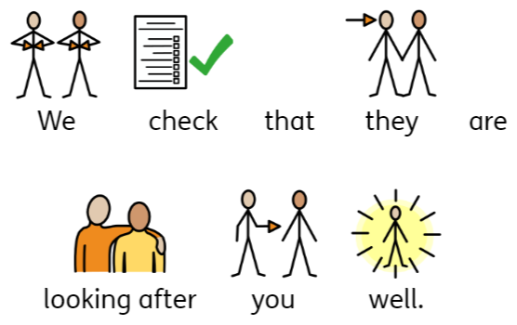

We check that they are



Looking after you well

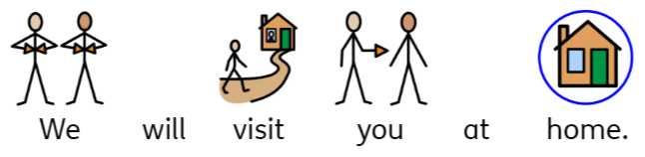

**We will visit you at home**

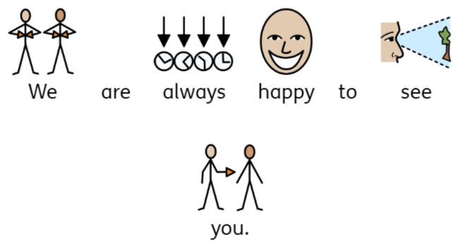

We are always happy to see



you.



**Who will I meet?**

|  |  |
| --- | --- |
| C:\Users\tracey.sorrell\AppData\Local\Microsoft\Windows\INetCache\Content.MSO\3C16F900.tmp  Name | C:\Users\tracey.sorrell\AppData\Local\Microsoft\Windows\INetCache\Content.MSO\3C16F900.tmp  Name |
| C:\Users\tracey.sorrell\AppData\Local\Microsoft\Windows\INetCache\Content.MSO\3C16F900.tmp  Name | C:\Users\tracey.sorrell\AppData\Local\Microsoft\Windows\INetCache\Content.MSO\3C16F900.tmp  Name |



**What about school?**

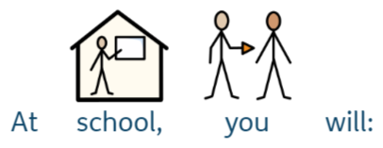

At school you will

|  |  |
| --- | --- |
| C:\Users\tracey.sorrell\AppData\Local\Microsoft\Windows\INetCache\Content.MSO\A40B5EF9.tmp  Make friends |  |
|  | C:\Users\tracey.sorrell\AppData\Local\Microsoft\Windows\INetCache\Content.MSO\4FA6C3A4.tmp  Learn |
| C:\Users\tracey.sorrell\AppData\Local\Microsoft\Windows\INetCache\Content.MSO\7F87C6BE.tmp  Enjoy activities |  |



If you can’t stay at your old school,



We will help find a new school for you.



We will help you settle in and do well.



**What if I’m unhappy?**



Tell us if you

|  |  |
| --- | --- |
| C:\Users\tracey.sorrell\AppData\Local\Microsoft\Windows\INetCache\Content.MSO\BACFE9DF.tmp | feel unhappy |
| C:\Users\tracey.sorrell\AppData\Local\Microsoft\Windows\INetCache\Content.MSO\130E9782.tmp | feel worried |
| C:\Users\tracey.sorrell\AppData\Local\Microsoft\Windows\INetCache\Content.MSO\A284AE2C.tmp | feel scared |



**Who can I tell?**

|  |  |
| --- | --- |
| C:\Users\tracey.sorrell\AppData\Local\Microsoft\Windows\INetCache\Content.MSO\3C16F900.tmp  Name of foster parent | C:\Users\tracey.sorrell\AppData\Local\Microsoft\Windows\INetCache\Content.MSO\3C16F900.tmp  Name of manager |
| C:\Users\tracey.sorrell\AppData\Local\Microsoft\Windows\INetCache\Content.MSO\3C16F900.tmp  Name of SSW | C:\Users\tracey.sorrell\AppData\Local\Microsoft\Windows\INetCache\Content.MSO\3C16F900.tmp  Name of FA |

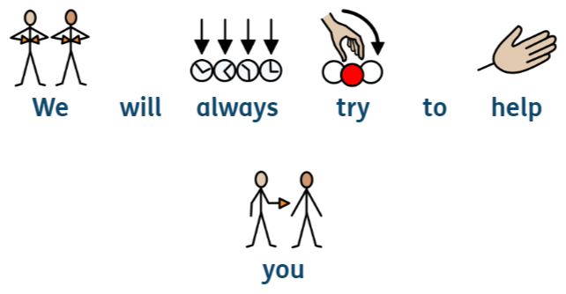

We will always try to help



you.



**How to contact us at ISP**

|  |  |
| --- | --- |
| C:\Users\tracey.sorrell\AppData\Local\Microsoft\Windows\INetCache\Content.MSO\66EE0447.tmp | Phone us  [insert number] |

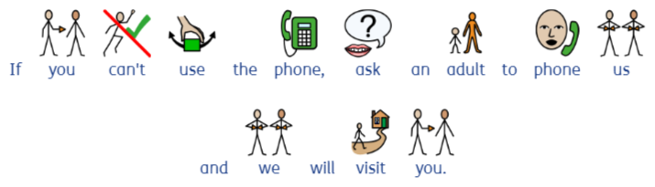

If you can’t use the phone, ask an adult to phone us



and we will visit you.



**Helpful numbers**

|  |  |
| --- | --- |
| C:\Users\tracey.sorrell\AppData\Local\Microsoft\Windows\INetCache\Content.MSO\A9D4AFB7.tmp  Your social worker |  |
| C:\Users\tracey.sorrell\AppData\Local\Microsoft\Windows\INetCache\Content.MSO\73282E3A.tmp  Childline | 0800 11 11 |
| C:\Users\tracey.sorrell\AppData\Local\Microsoft\Windows\INetCache\Content.MSO\840CEE79.tmp  The Children’s Commissioner | 0800 528 0731 |
| C:\Users\tracey.sorrell\AppData\Local\Microsoft\Windows\INetCache\Content.MSO\2BAA4924.tmp  Ofsted | 0300 123 1231 |