

**Welcome to ISP**

C:\Users\tracey.sorrell\AppData\Local\Microsoft\Windows\INetCache\Content.MSO\15224F9F.tmp

Child’s name here

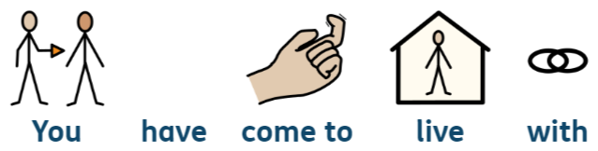

You have come to live with



Name of foster family here

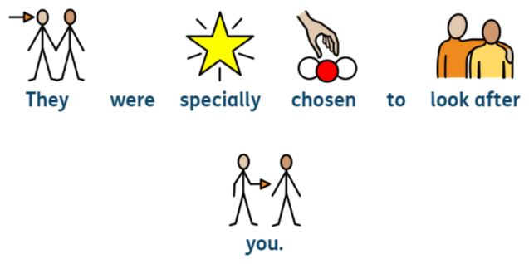

They were specially chosen to look after



you.

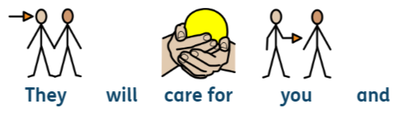

They will care for you and

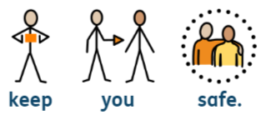

keep you safe.

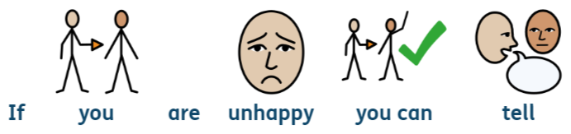

If you are unhappy you can tell



Name of foster family here

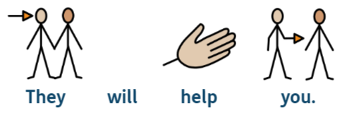

They will help you

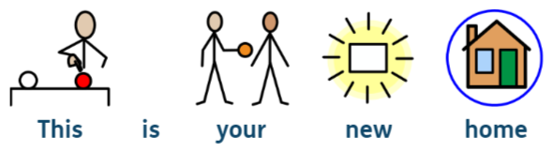

This is your new home



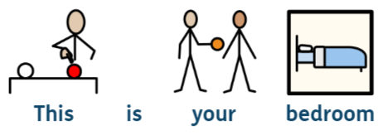

This is your bedroom

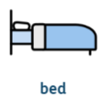

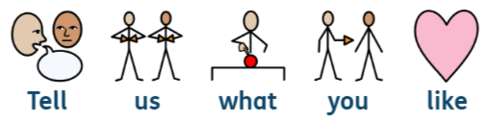

Tell us what you like

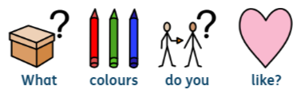

What colours do you like?

|  |  |  |
| --- | --- | --- |
| C:\Users\tracey.sorrell\AppData\Local\Microsoft\Windows\INetCache\Content.MSO\68EDABBB.tmp | C:\Users\tracey.sorrell\AppData\Local\Microsoft\Windows\INetCache\Content.MSO\E8B4C7F4.tmp | C:\Users\tracey.sorrell\AppData\Local\Microsoft\Windows\INetCache\Content.MSO\DA678E09.tmp |
| C:\Users\tracey.sorrell\AppData\Local\Microsoft\Windows\INetCache\Content.MSO\E77EFB8A.tmp | C:\Users\tracey.sorrell\AppData\Local\Microsoft\Windows\INetCache\Content.MSO\96DD43C7.tmp | C:\Users\tracey.sorrell\AppData\Local\Microsoft\Windows\INetCache\Content.MSO\3F1548D0.tmp |
| C:\Users\tracey.sorrell\AppData\Local\Microsoft\Windows\INetCache\Content.MSO\41EF075.tmp | C:\Users\tracey.sorrell\AppData\Local\Microsoft\Windows\INetCache\Content.MSO\FCA9E546.tmp | C:\Users\tracey.sorrell\AppData\Local\Microsoft\Windows\INetCache\Content.MSO\9EA61393.tmp |

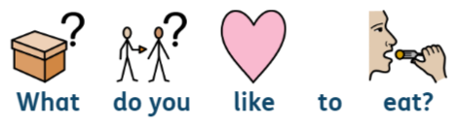

What do you like to eat?

|  |  |  |
| --- | --- | --- |
| C:\Users\tracey.sorrell\AppData\Local\Microsoft\Windows\INetCache\Content.MSO\3C47AA1E.tmp | C:\Users\tracey.sorrell\AppData\Local\Microsoft\Windows\INetCache\Content.MSO\FE3AF22D.tmp | Fish & Chip Day 2021: Our favourite fish & chip shops in the north and  north-east |
| Why Does Swiss Cheese Have Holes? | Wonderopolis | C:\Users\tracey.sorrell\AppData\Local\Microsoft\Windows\INetCache\Content.MSO\ED21537B.tmp | Homemade Bread Recipe - Tastes Better from Scratch |
| Will Eating More Vegetables Cause you to Gain Weight? - Spend Smart Eat  Smart | Spaghetti with Clams Recipe | C:\Users\tracey.sorrell\AppData\Local\Microsoft\Windows\INetCache\Content.MSO\CAE4BA66.tmp |

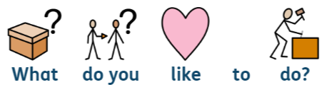

What do you like to do?

|  |  |  |
| --- | --- | --- |
| C:\Users\tracey.sorrell\AppData\Local\Microsoft\Windows\INetCache\Content.MSO\D3AAA8.tmp  Dancing | C:\Users\tracey.sorrell\AppData\Local\Microsoft\Windows\INetCache\Content.MSO\5916A67F.tmp  Singing | C:\Users\tracey.sorrell\AppData\Local\Microsoft\Windows\INetCache\Content.MSO\1F38A0A2.tmp  Lego |
| C:\Users\tracey.sorrell\AppData\Local\Microsoft\Windows\INetCache\Content.MSO\5BF9501.tmp  Play park | C:\Users\tracey.sorrell\AppData\Local\Microsoft\Windows\INetCache\Content.MSO\17EE864C.tmp  Beach | C:\Users\tracey.sorrell\AppData\Local\Microsoft\Windows\INetCache\Content.MSO\9610E4F3.tmp  Games |
| C:\Users\tracey.sorrell\AppData\Local\Microsoft\Windows\INetCache\Content.MSO\7E638226.tmp  Computer | C:\Users\tracey.sorrell\AppData\Local\Microsoft\Windows\INetCache\Content.MSO\A127FED5.tmp  Computer games | C:\Users\tracey.sorrell\AppData\Local\Microsoft\Windows\INetCache\Content.MSO\6FD26727.tmp  Music |



You will meet some adults at ISP

|  |  |
| --- | --- |
| C:\Users\tracey.sorrell\AppData\Local\Microsoft\Windows\INetCache\Content.MSO\3C16F900.tmp  Name | C:\Users\tracey.sorrell\AppData\Local\Microsoft\Windows\INetCache\Content.MSO\3C16F900.tmp  Name |
| C:\Users\tracey.sorrell\AppData\Local\Microsoft\Windows\INetCache\Content.MSO\3C16F900.tmp  Name | C:\Users\tracey.sorrell\AppData\Local\Microsoft\Windows\INetCache\Content.MSO\3C16F900.tmp  Name |

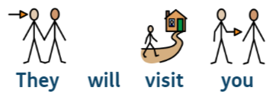

They will visit you



They will make sure that you are



safe and happy.

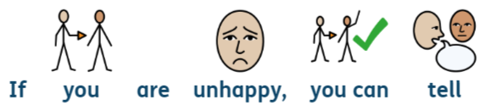

If you are unhappy you can tell

|  |  |
| --- | --- |
| C:\Users\tracey.sorrell\AppData\Local\Microsoft\Windows\INetCache\Content.MSO\3C16F900.tmp  Name of foster parent | C:\Users\tracey.sorrell\AppData\Local\Microsoft\Windows\INetCache\Content.MSO\3C16F900.tmp  Name of manager |
| C:\Users\tracey.sorrell\AppData\Local\Microsoft\Windows\INetCache\Content.MSO\3C16F900.tmp  Name of SSW | C:\Users\tracey.sorrell\AppData\Local\Microsoft\Windows\INetCache\Content.MSO\3C16F900.tmp  Name of FA |



Your new school



Name of school



Your new teacher



Name of teacher